**MBF Archival retrieval**

All the MBF codes store their data in a common location with programmatically constructed names. Therefore, it is possible to extract and compare this data.

**Code location**

Git clone <https://github.com/alunmorgan/Multi-bunch-feedback-applications.git>

Add the resulting folder to your Matlab path.

**Getting the latest data**

The simplest thing is to look at the last results taken. To do this simply run the command below on the Matlab command line.

**>> visualise_latest_mbf_results**

Below is an example of the output for Growdamp and Modescan measurements

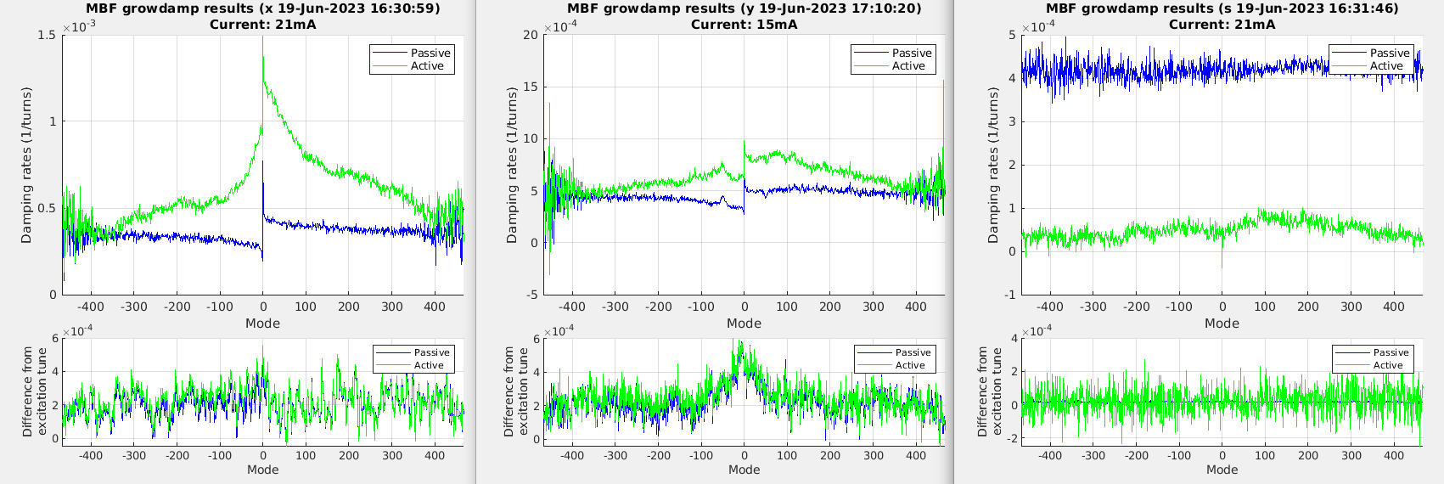

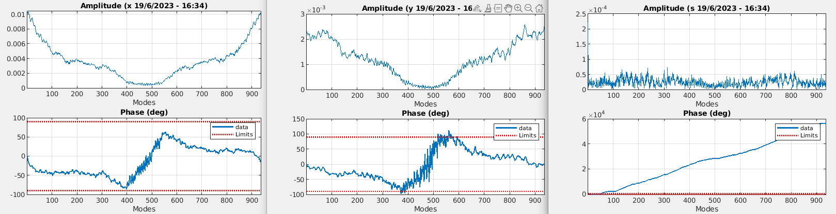

It is possible to change the x axis of the Growdamp measurement by using the growdamp_plot_mode optional input.

**>> visualise_latest_mbf_results('growdamp_plot_mode', 'freq')**

Will put the output on a frequency scale rather than the usual mode scale

**>> visualise_latest_mbf_results('growdamp_plot_mode', 'pos')**

Will reorganise the modes to be numbered 0:935 rather than –468:468

**Getting any historic data**

A more flexible way is to set up the time period you are interested in looking at and use the measurement specific retrieval tool.

You can set up the period of interest using the following code.

**>> start_datenum = datetime('16/04/2023_21:38','InputFormat','dd/MM/yyyy_HH:mm');**

**>> end_datenum = datetime('16/06/2023_22:55','InputFormat','dd/MM/yyyy_HH:mm');**

**>> date_range = [start_datenum, end_datenum];**

Starting with growdamp data, the following command will extract any measurements taken within the date range for the y axis and then plot them on top of one another.

**>> conditioned_data = mbf_growdamp_archival_retrieval('y', date_range);**

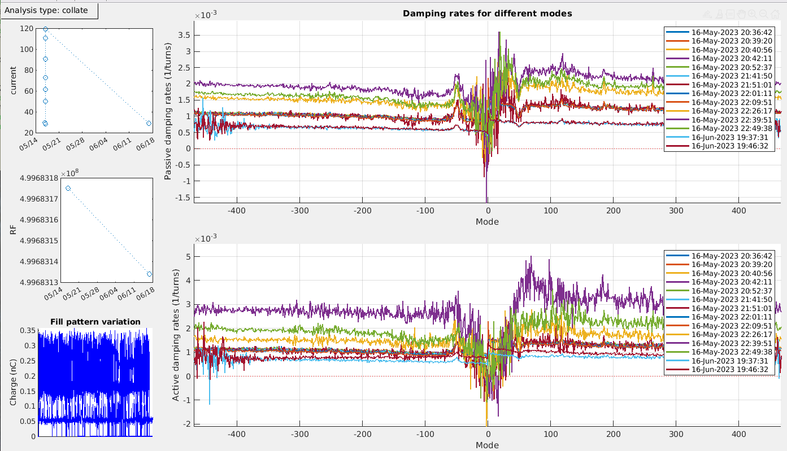

This allows easy identification of changes in behaviour

As machine conditions can be different it is possible to filter on current range and RF frequency range

For example, by setting the current_range optional input we can select only measurements which were taken between 2mA and 40mA

**>> conditioned_data = mbf_growdamp_archival_retrieval('y', date_range, 'current_range', [2 40]);**

This is often useful to ensure that any measurements used are below instability thresholds.

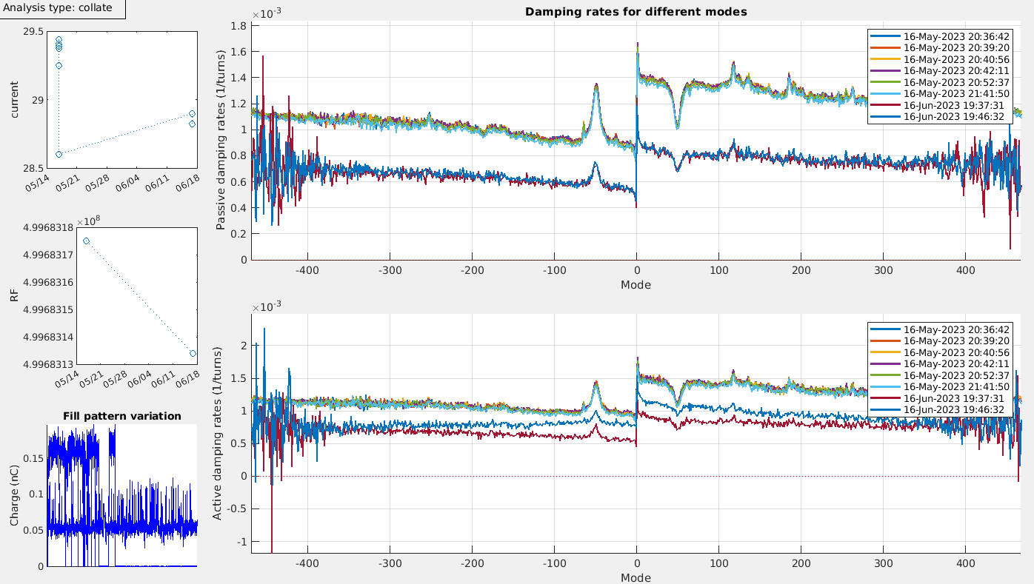

One common set of measurements beyond simple comparisons is plotting the measurements against a changing machine parameter (usually current)

Although it is possible to extract such relationships from the data just using the variation over time, it is more usual to have a dedicated measurement set for the purpose. In this case you would set the period to only contain data from that experiment. Then you would run the retrieval with the analysis type set to sweep and then set the appropriate parameter to sweep over (again it is usually current but any variable in the datasets can be used).

**>> conditioned_data = mbf_growdamp_archival_retrieval('y', date_range, 'analysis_type', 'sweep', 'sweep_parameter', 'current');**

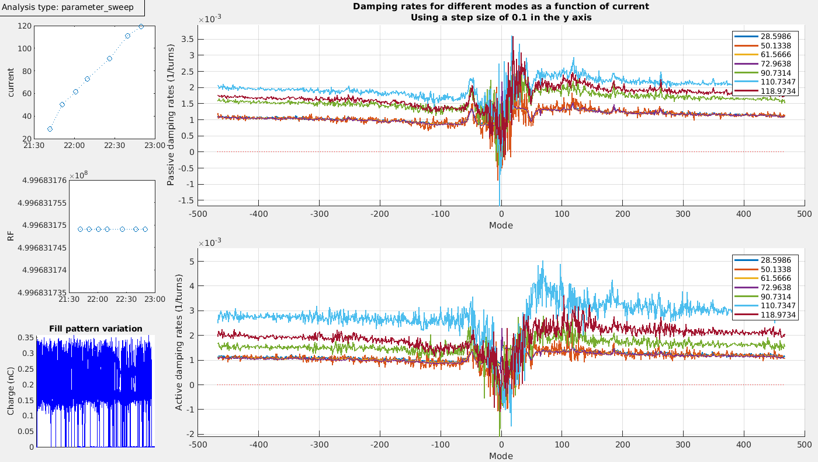

At this point further analysis is possible. In the case of a current sweep, it is possible to predict the current which individual modes will go unstable.

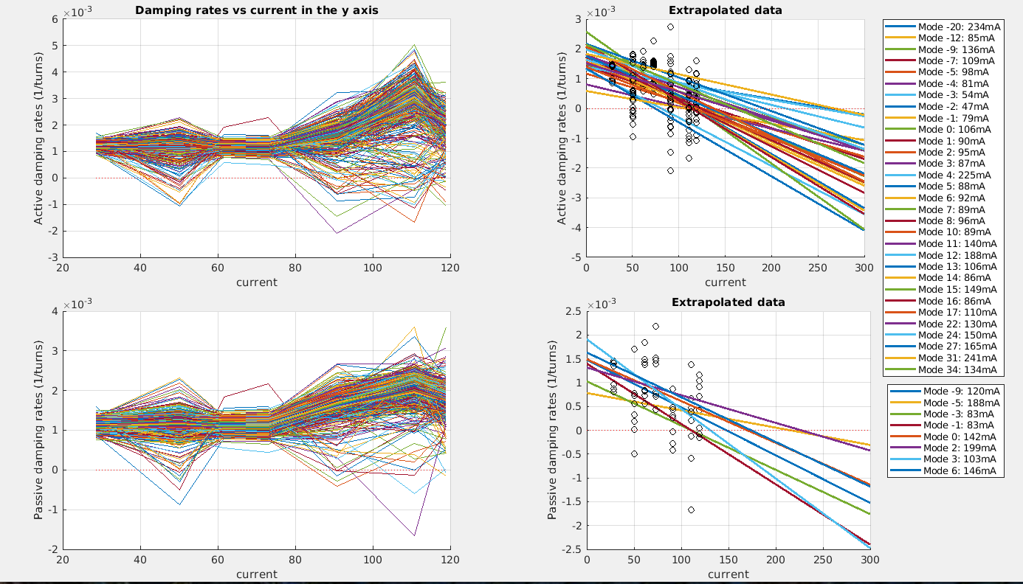

Note: These are placeholder graphs.

Modescan data retrieval is much the same as the growdamp retrieval. Once the date range is set up the following code will extract and display all results from the y axis.

**>> conditioned_data = mbf_modescan_archival_retrieval('y', date_range);**

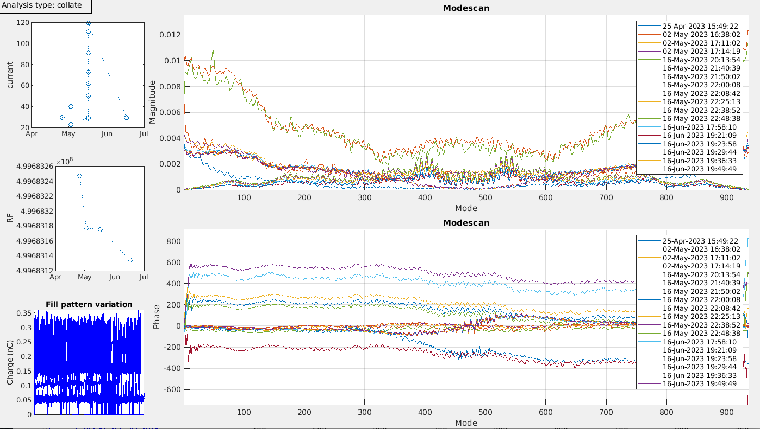

As before you can filter on current range.

**>> conditioned_data = mbf_modescan_archival_retrieval('y', date_range, 'current_range', [2 40]);**

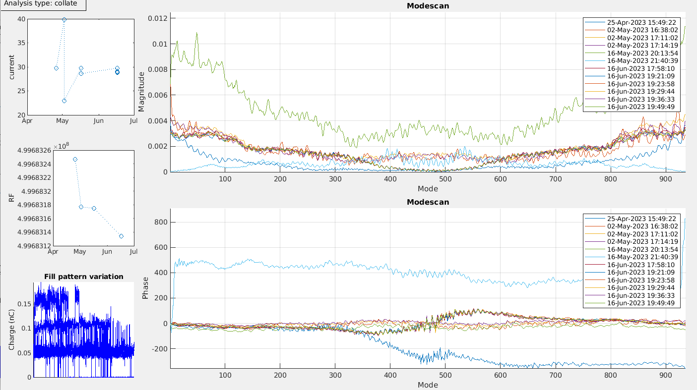

And can plot against a parameter sweep

**>> conditioned_data = mbf_modescan_archival_retrieval('y', date_range, 'analysis_type', 'sweep', 'sweep_parameter', 'current');**

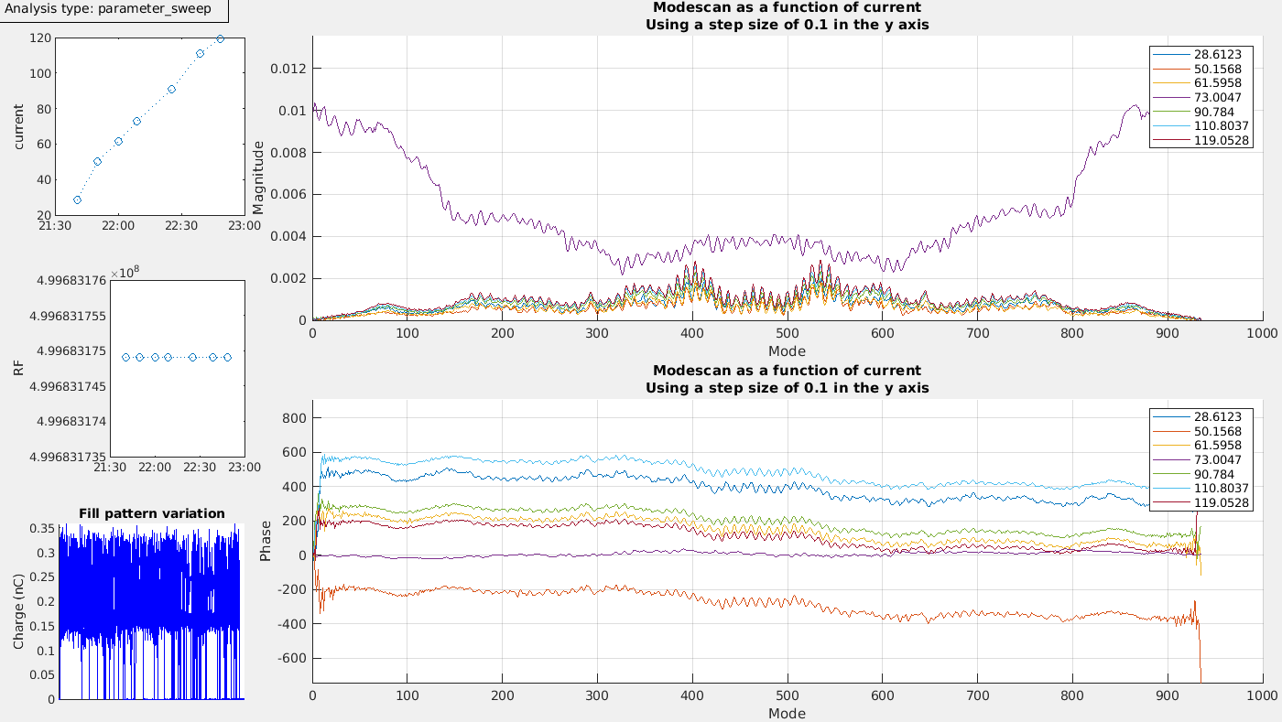

Spectra

Tune sweep over modes

Frontend system phase scan